Gluten-Free Diet

A Gluten-Free Diet and Your Health
If you have celiac disease, it is very important that you do not eat gluten. Gluten is a protein found in wheat, barley and rye. Following a diet without gluten can help you control your disease. It is the most important part of your treatment. Avoiding gluten can help prevent long-term health problems.
Celiac disease tends to run in families. If you think a family member may have celiac disease, testing is important. But be sure to have testing done before trying a gluten-free diet. Eating a gluten-free diet before testing can affect results.

Health problems

Celiac disease
Celiac disease is a digestive condition that affects the small intestine. When you have celiac disease, eating gluten can damage the lining of your small intestine. This damage can keep the small intestine from absorbing important nutrients from foods.

Dermatitis herpetiformis
Dermatitis herpetiformis is a severe skin rash related to celiac disease. It can result in an itchy rash and blisters. The rash usually happens on the elbows, knees and buttocks. But it also can happen on other parts of your body. This condition can damage the small intestine.
The only treatment for celiac disease is to strictly follow a gluten-free diet. Dermatitis herpetiformis is also treated by a gluten-free diet. And it is also treated with medication for skin rashes or blisters.
Celiac disease and dermatitis herpetiformis may lead to:
- Bone thinning, also called osteoporosis.
- Lack of iron, also called anemia.
- Nerve damage.
- Certain kinds of cancer.
- Growth problems in children.

Non-celiac gluten sensitivity
If you have non-celiac gluten sensitivity, you may have symptoms like those of celiac disease. However, all tests you have for celiac disease are negative. And your intestine is not damaged.
Non-celiac gluten sensitivity also is known as NCGS. If you have this condition, you may not have to follow a strict gluten-free diet. Talk with your health care provider about your diet and your non-celiac gluten sensitivity.

How a gluten-free diet helps you
Following a gluten-free diet can:
- Heal intestinal damage.
- Keep new intestinal damage from happening.
- Make you feel better.
- Get rid of all or most of your symptoms.
- Correct low levels of vitamins or minerals in your blood.
- Heal skin rashes caused by dermatitis herpetiformis.
- Prevent complications.
Once you stop eating foods that have gluten, healing begins within a few days. However, complete healing may take months or even years. Healing time depends on:
- Your age. Young people heal more quickly.
- How long you have had the disease.
- How much damage has been done to the small intestine.
- Your overall health.
- How much gluten gets into your diet.

When symptoms do not go away
Even on a strict gluten-free diet, some symptoms may not go away. You and your health care provider may need to look closely at your diet. Some symptoms may not go away because you do not know you are eating small amounts of gluten.
Intestinal damage usually improves when you follow a strict gluten-free diet. However, you may still have symptoms. In that case, you may need more medical tests to see whether you have other health problems. You may need medication or other treatment plans.

Staying on a gluten-free diet for life
You must stay on a gluten-free diet for the rest of your life. The change to a gluten-free diet can take time and patience. For many, this is a whole new way to eat. The first several months may challenge you. Sometimes you may eat something by mistake that has gluten. You may crave foods you should not eat. Eating gluten-free gets easier with time. And the rewards are worth it.
You may not have symptoms when you eat small amounts of gluten. However, this does not mean it is safe to do so. Damage happens even when you do not have symptoms. If you continue to eat foods with even small amounts of gluten, you may have health problems for a long time.
Help is available to guide you. You can make a gluten-free diet an enjoyable and healthy part of your life. Your dietitian, support groups, reputable websites, and gluten-free cookbooks are all good resources.

Eating foods with gluten by mistake
By mistake, you may eat something that has gluten. This may lead to abdominal pain or diarrhea. If this seems to happen a lot, consider talking to your dietitian. Review your dietary guidelines. Make sure you know what you should and should not eat. Make sure you can identify hidden sources of gluten.
If symptoms happen after you eat a certain food, look closely at the ingredients list of the food to see whether it has gluten.
Report any symptoms to your health care provider.

Your family and your diet
The gluten-free diet can be a balanced, healthy diet. All family members can eat it as long as you choose enriched and fortified grain products. Many gluten-free flours and cereals are not enriched or fortified.
It may be easier when the whole family eats the same foods and meals. And your family may enjoy sampling a variety of gluten-free products to offer encouragement and support. However, it can be costly to feed gluten-free products to a family.

Frequently asked questions
Can I “cheat” occasionally and eat something with gluten?
Even if you eat something with gluten and do not get symptoms, it can still damage your intestine and interfere with healing. It is recommended that you follow a gluten-free diet at all times.
What if I accidently eat something with gluten? What should I do?
First, try to prevent accidents by using your gluten-free diet guidelines. Do your best to plan and be prepared. If you eat something with gluten, return to the gluten-free diet. There is no antidote for gluten exposure.
How much exposure to gluten does it take to experience symptoms or cause damage?
There is no general rule that applies to all people. Some people are more sensitive than others. And not all people experience symptoms with exposure. Even if you do not experience symptoms, it does not mean it is safe to consume foods that contain a small amount of gluten. The gluten could still be damaging your small intestine.
Can I get all the nutrients I need from a gluten-free diet?
Yes, but you must select your food choices wisely. To get all the nutrients you need, eat a variety of foods each day. Include fish, meat and poultry. Eat legumes, which include beans, peas and lentils. Eat dairy, fruits and vegetables. Also include gluten-free whole grains, such as corn, gluten-free oats, quinoa, and enriched or fortified gluten-free grains.

Gluten in the Food You Eat

Grains with gluten
Gluten is a protein found in wheat, rye and barley. These are common grains. They are in foods such as:
- Breads
- Croutons
- Cereals
- Crackers
- Pasta
- Cakes
- Cookies
- Pies
- Gravies
- Sauces
Don’t eat these foods unless they are made with gluten-free ingredients.
Gluten-free flours can be used for baking. Many stores stock prepared gluten-free products. These include breads, pasta, baking mixes, and cereal. Check your local health food store and larger grocery stores. Or look online for companies that sell gluten-free products. Ask your dietitian to help you find gluten-free products.

Other foods with gluten
Some less obvious foods that may contain gluten include:
- Salad dressing
- Cornflakes
- Candy
- Corn chips
- Soy sauce
- Rice cereal

Gluten-free foods
Fortunately, many foods are gluten-free. Naturally gluten-free foods that you can eat include:
- Plain meats, poultry, fish, and eggs
- Fruits
- Vegetables
- Corn
- Rice
- Potatoes
- Legumes (beans, peas and lentils)
- Seeds and nuts
- Many dairy products

Finding out whether food has gluten
To follow a gluten-free diet, it is important that you know how to read a food label. A food does not need to be labeled gluten-free in order for it to be safe. There are other ways to find out whether food has gluten. One way is to read the ingredient list on the package. Look for words that show that the food may have gluten.

Ingredients that show a food has gluten
If a food label lists any of the following ingredients, that food has gluten:
- Wheat or variations of wheat. They include wheat flour, white flour, wheat bran, wheat germ, wheat starch, farina, and graham flour. They also include semolina, durum, wheat berries, hydrolyzed wheat protein, bulgur, and kamut. And they include matzo meal, spelt, triticale, einkorn, and emmer.
- Barley.
- Rye.
- Malt, malt flavoring, malt vinegar, malt syrup, malt extract and other forms of malt.
- Oats, unless gluten-free.
- Brewer’s yeast.
New grains are always being added to the market. Do not use new grains until you know they are safe to eat. Wheat-free does not mean gluten-free. If you do not know for sure, do not eat the product. Talk to your dietitian if you have questions.
Check the ingredient list for any of the ingredients listed above. Do not eat foods with those ingredients.

Gluten-free labeling
If a manufacturer chooses to label an item “gluten-free,” the item must comply with the FDA definition. FDA is a short form for the Food and Drug Administration. The item must have less than 20 parts per million (ppm) of gluten. Twenty ppm has been found to be safe for people with celiac disease. Foods labeled as “without gluten” or “free of gluten” or “no gluten” also are considered to be gluten-free.
Statements such as “no gluten-containing ingredients” or “low-gluten” are not the same as being completely free from gluten.
Manufacturers are not required to test for the presence of gluten in products labeled as “gluten-free.” However, they are responsible to ensure that the food product meets all labeling requirements.
Certified gluten-free means that the product has been tested by an independent third-party organization to ensure it is gluten-free. Products that are certified gluten-free are required to have a lower limit for gluten. Usually they have to have less than 10 ppm.
Certified gluten-free products have their facility production processes analyzed to ensure they meet good manufacturing practices.
FDA regulations apply to most foods and beverages. This includes packaged foods, dietary supplements, fruits and vegetables, eggs with shells, and fish. FDA regulations do not include:
- Meat and poultry.
- Eggs without shells or eggs that are dried or powdered.
- Most alcoholic beverages.
There is no requirement that gluten-free foods must be labeled “gluten-free.” Therefore, there are many gluten-free foods that are not labeled as gluten-free.
If you have any doubts about a product’s ingredient list, contact the manufacturer or check their website for more information.

Reading food labels
When you have celiac disease, you need to know how to read a food label. Food companies are required by law to list the eight most common ingredients that trigger food allergies. Foods that trigger allergies are called allergens. These items are milk, eggs, peanuts, tree nuts, fish, shellfish, soy, and wheat. The only ingredient people with celiac disease need to avoid is wheat.
You may see a “contains” statement near the bottom of a food label. The statement must include the food source names of all major food allergens used as ingredients. See Figure 1 for an example of a food label that contains wheat.
If you do not see wheat listed in the “contains” statement, you still must check the ingredients. Sometimes the manufacturer will not list wheat in the statement because it is also listed in the ingredients. See Figure 2.
Carefully read both the “contains” statement, if there is one, and the ingredients list to find items that may contain wheat.
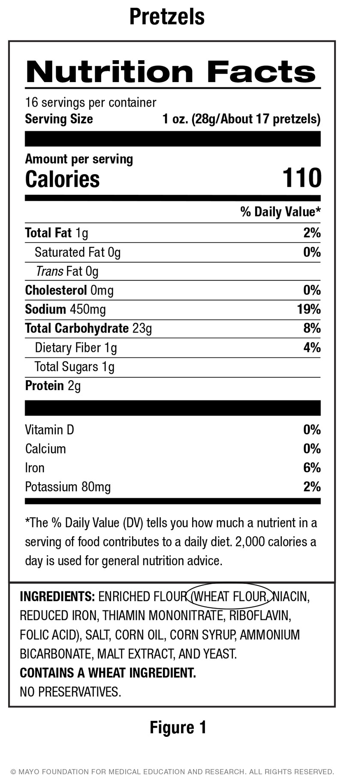
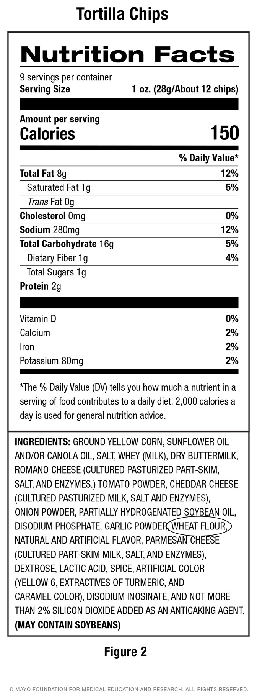

Meat, poultry, and egg products
Meat, poultry and unshelled egg products are not required by law to include an allergen statement. However, many manufacturers do list allergens anyway. If you do not see an allergen statement or a gluten-free label on a meat, poultry or unshelled egg product, do not eat it until you can make sure it is gluten-free. Whole, unprocessed meat, poultry and unshelled eggs are naturally gluten-free. Ingredients that may indicate the presence of gluten in processed meat, poultry or eggs include:
- Starch.
- Modified food starch.
- Dextrin.
If starch, modified food starch or dextrin is included in an ingredient list for processed meat, poultry or unshelled eggs, contact the manufacturer and ask if the product contains wheat.

More on food labels
Read the ingredients and food labels even when you buy products you’ve eaten before without a problem. Manufacturers often change ingredients. A food product that was once gluten-free and safe to eat may have its ingredients changed. And it can no longer be safe.

Allergen advisory statements and cross-contamination
Manufacturers may choose to include statements on product labels to let people with allergies know food is made in a facility where wheat or other allergens may be present. This may lead to cross- contamination. This happens when gluten-free foods come into contact with foods that have gluten.
Allergen advisory statements include “May contain wheat,” “Processed in a facility that uses wheat” and “Produced on equipment that also processes wheat.”
In the United States, allergen advisory statements are considered voluntary. These statements are not to be used as a replacement for good manufacturing practices.
When following a gluten-free diet, these advisory statements need not cause worry. Manufacturers whose labels have these warnings are still required to use practices to avoid cross-contamination.
- If you see an advisory statement on a product labeled “gluten-free,“ it is gluten-free.
- If you see an advisory statement on a product not labeled “gluten-free,” it does not mean the food is contaminated with gluten.
However, for some products that are not labeled gluten-free, there is a higher risk of cross-contamination with gluten. These are products that include oats, lentils and milled products made from grains, beans, seeds, or legumes. Soy flour, sorghum flour, garbanzo bean flour, and ground flax also have a higher risk of cross-contamination.
All grains are cross-contaminated to some degree by the way they are grown, transported or milled. These products should only be eaten if labeled gluten-free. Products whose ingredient lists don’t contain these items or other forms of gluten should be safe to eat.

Other ways to learn about ingredients
If you can’t tell from the ingredient list and food label whether a product has gluten, contact the manufacturer. Check the food label for a phone number. Call and ask for information. Or look up the manufacturer on the internet. Check at least once a year to make sure that information hasn’t changed.

Other sources of cross-contamination
A hidden source of gluten comes from cross-contamination. This may happen anywhere foods come together. Cross-contamination can happen in your home, in restaurants or at places where food is grown or processed.
Examples of how cross-contamination can happen at home:
- Using a toaster that has been used to toast food with gluten.
- Sifting flour close to other foods.
- Using spreads that may have bread crumbs in them. Butter, margarine and peanut butter are examples.
- Forgetting to wipe the countertop.
- Using common kitchen items that may be hard to clean. Examples include strainers, colanders, bread machines, and cutting boards as well as grills, waffle irons and flour sifters.
If kitchen items that are hard to clean have been used with wheat products, they should be replaced with new items. You may use the same pots, pans, dishes, and flatware as long as they are washed with soapy water between use.
Other possible sources of cross-contamination:
- Serving spoons at a salad bar, cafeteria or buffet.
- Scoops used to scoop bulk items at a store.
- Deep-fried foods cooked in oil that was used to cook items breaded with wheat.
- Places where food is grown or during transportation of food items.

Oats
Oats do not have gluten, but gluten can cross-contaminate them during harvesting or processing. Some oats are certified as gluten-free. These may be okay for some people to eat. However, do not try these until your celiac disease or dermatitis herpetiformis is under good control for at least a year and you have talked to your physician or dietitian. This is because some people with celiac disease are sensitive to oats that are labeled gluten-free.

Non-food products that may have gluten
Food isn’t the only source of gluten. However, only products that enter your mouth can harm you.
Some of these products include:
- Prescription medications and medications you buy over the counter.
- Herbal and vitamin supplements.
- Oral care products, such as toothpaste or mouth rinses, although most are gluten-free.
- Play dough, which some children may put in their mouths.
If you are not sure whether something has gluten, contact the company. Talk to a pharmacist about medications you need to take. Ask about gluten-free versions. You cannot tell by reading the ingredient list whether these products are gluten-free.
Skin care or hair care products do not need to be gluten-free.

Gluten-free foods you may not be able to eat
If gluten has damaged your small intestine badly enough, even some gluten-free foods may cause diarrhea and abdominal pain. Foods other than gluten can cause symptoms but won’t cause damage to your intestine. Dairy products can be an issue. Once you follow a gluten-free diet and your intestine heals, you may be able to have these foods without problems.

Calcium and vitamin D
Calcium and vitamin D are important for everyone, especially people who have celiac disease. If you have celiac disease, your body may not absorb calcium and vitamin D very well. This can lead to weak bones, also called osteoporosis. If you cannot eat or drink dairy products, consider taking a gluten-free calcium supplement with vitamin D.

Foods for a Gluten-Free Diet
When you start a gluten-free diet, you may feel like many foods have been taken away from you. But you still do have many enjoyable and healthy choices.
Use the following food guide to learn which foods you can include in your diet. However, don’t use this guide alone.
Always read food labels and contact manufacturers when you are not sure about ingredients.
Keep in mind that foods may or may not contain gluten. It depends on how they are prepared. Before you eat any product, make sure all ingredients are gluten-free and safe to eat.
Remember that even though some grains and legumes are gluten-free as grown, they may become contaminated during harvesting or processing. Only grains that are labeled gluten-free should be considered free of gluten. For products that are not labeled gluten-free, there is a higher risk of cross-contamination with gluten. These are products that include oats, lentils, and milled products made from grains, beans, seeds, or legumes. Sorghum flour, garbanzo bean flour and ground flax also have a higher risk of cross-contamination with gluten. Consider choosing only grain items that are labeled gluten-free.

Grains and grain products

Gluten-free
- Specially prepared breads made with rice, potato, soy, or other allowed flours  - Cereals made from pure corn, rice or other allowed grains  - Grits and hominy  - Rice, including white, brown, wild, Arborio, glutinous, basmati, and other unseasoned rice  - Cornmeal and corn flour  - Pasta made from corn, rice or other allowed flours  - Polenta  - Arrowroot starch  - Bean flours  - Chickpea flour, also called garbanzo bean flour  - Coconut flour  - Lentil flours | - Nut flours  - Sorghum flour  - Millet  - Quinoa  - Pure buckwheat  - Amaranth  - Teff  - Kasha (buckwheat groats)  - Flax  - Potato starch and flour  - Soy flour  - Rice flour  - Pure corn tortillas  - Plain rice cakes  - Tapioca flour and starch

May have gluten
- Commercial seasoned rice and potato mixes  - Corn tortillas  - Flavored rice crackers | - Flavored rice cakes  - Products made with buckwheat flour  - Buckwheat pasta  - Instant potatoes

Contains gluten
- All breads, cereals, crackers, pastas, and other products that contain wheat, rye, barley, oats, wheat bran, wheat starch, malt, malt flavoring, farina, bulgur, kamut, matzo, semolina, spelt, triticale, or other gluten-containing products  - All flours made from wheat, barley or oats, including white flour, graham flour, durum flour, and pastry flour  - Commercial corn muffins and corn bread unless labeled gluten-free  - Corn and rice cereals made with malt or malt flavoring or other gluten-containing ingredients | - Croutons  - Pancakes and waffles  - Bread-based stuffing and dressing  - Dumplings  - Flour tortillas  - Pretzels  - Wraps  - Wontons  - Communion wafers  - Breading and coating mixes  - Couscous

Meat and meat substitutes

Gluten-free
- Plain meat, poultry, fish and shellfish  - Most brands of peanut butter, but you should check the ingredients  - Eggs | - Dried peas and beans  - Lentils  - Pure tofu  - Plain canned tuna or salmon

May have gluten
- Meat patties or frozen burgers  - Hot dogs  - Cold cuts  - Deli meats  - Sausages  - Sandwich spreads  - Canned meat and fish  - Self-basting turkey  - Imitation meat products, such as vegetable burgers or imitation bacon | - Soufflés  - Commercial omelets  - Fondue  - Commercial chili and stews  - Imitation seafood  - Seasoned tofu  - Egg substitutes  - Tempeh, a soy-based food  - Miso, a soy-based food  - Marinated meat, poultry or fish

Contains gluten
- Meat, poultry or fish made with bread, bread crumbs, cracker crumbs, or other gluten-containing breading or batter  - Most meatloaves and meatballs  - Swiss steak | - Croquettes  - Pizza  - Seitan, a vegetarian meat substitute

Milk and milk products

Gluten-free
- Skim, low-fat and whole white milk  - Powdered milk  - Buttermilk  - Evaporated milk  - Real cheese, such as cheddar, mozzarella or Swiss | - Pure cream  - Half-and-half  - Sweetened condensed milk  - Coconut milk  - Yogurt, plain or flavored

May have gluten
- Chocolate milk  - Instant milk drinks and cocoa mixes  - Cottage cheese  - Cream cheese  - Processed cheese, including American and cheese spreads | - Yogurt with granola or other added items that may have gluten  - Sour cream  - Whipped topping  - Non-dairy milk substitutes, such as soy milk

Contains gluten
- Milk or other beverages that contain malt or other gluten-containing ingredients

Vegetables

Gluten-free
- Plain fresh, frozen, or canned vegetables  - Vegetable juices  - Potatoes |  | - Most brands of pickles, but you should check the ingredients  - Olives, plain or pimento

May have gluten
- Pasta sauce  - Seasoned vegetable mixes  - Baked beans | - French fries and hash browns  - Stuffed olives that are not pimento

Contains gluten
- Breaded or batter-fried vegetables | - Vegetables with cream sauce, cheese sauce or other sauce

Fruits

Gluten-free
- Plain fresh, frozen or canned fruits  - Pure fresh, frozen or canned fruit juice |  | - Fruit thickened with tapioca or corn starch  - Most dried fruit

May have gluten
- Dates that may be dusted with flour | - Pie fillings

Contains gluten
- Fruits thickened with wheat or other flours that contain gluten

Fats and oils

Gluten-free
- Butter  - Most brands of margarine, but you should check the ingredients  - Cooking or salad oils, such as vegetable oil, olive oil and canola oil  - Shortening |  | - Lard  - Mayonnaise  - Gravy, cream sauces and white sauces thickened with cornstarch or allowed flours  - Wheat germ oil, but do not use unrefined, cold-pressed or expeller-pressed as those forms of wheat germ oil contain gluten

May have gluten
- Salad dressing  - Non-dairy creamer | - Cooking sprays  - Suet

Contains gluten
- Most gravies, cream sauces and white sauces | - Wheat germ oil that is unrefined, cold-pressed or expeller-pressed

Soups

Gluten-free
- Soups made with allowed ingredients

May have gluten
- Canned or packaged broth  - Bouillon | - Bouillon cubes

Contains gluten
- Most commercial soups and soup mixes  - Soup that has barley or pasta | - Soup thickened with wheat flour or other gluten-containing ingredients

Desserts

Gluten-free
- Gelatin  - Homemade custard  - Pudding and fruit filling thickened with tapioca, cornstarch, arrowroot starch, or flour  - Specially prepared or homemade cakes, cookies and pastries made with gluten-free ingredients |  | - Meringue  - Coconut  - Most commercial ice cream, ice milk, frozen yogurt, sherbet and fruit ice

May have gluten
- Pudding and custard mixes  - Whipped topping  - Baking chips | - Cake decorations  - Mincemeat

Contains gluten
- Commercial cakes, cookies, pies, quick breads, muffins, and pastries made with wheat, rye, barley, oats, or other gluten-containing ingredients  - Commercially prepared baking mixes made with wheat, rye, barley, oats, or other gluten containing ingredients | - Dumplings  - Ice cream cones  - Ice cream, ice milk or frozen yogurt with cookies or other add-ins that have gluten

Sweets

Gluten-free
- White sugar  - Brown sugar  - Jelly and jam  - Molasses | - Honey  - Pure maple syrup

May have gluten
- Marshmallows  - Artificial sweeteners  - Commercial candies  - Chewing gum |  | - Flavored syrups  - Brown rice syrup  - Rice syrup

Contains gluten
- Candy with gluten-containing ingredients | - Licorice

Snacks

Gluten-free
- Plain corn chips  - Plain potato chips  - Plain nuts | - Plain popcorn  - Plain rice cakes  - Plain rice crackers

May have gluten
- Seasoned popcorn (microwave or pre-popped popcorn) |  | - Many granola bars

Contains gluten
- Most crackers  - Pretzels | - Matzo

Beverages

Gluten-free
- Plain coffee and tea, including decaffeinated  - Wine, brandy, rum or vodka  - Gin, whiskey or other alcohol distilled from grains  - Juice | - Soda pop  - Gluten-free beer  - Apple cider

May have gluten
- Any beverages made from a mix  - Herbal and instant teas  - Nutritional supplements  - Flavored coffees | - Beers labeled as processed, treated or crafted to remove gluten (safe beers are those that do not include wheat, rye or barley on the ingredient list)  - Diet drinks, such as weight-loss shakes  - Wine coolers  - Cocktails

Contains gluten
- Beer, including nonalcoholic beer, ale and lager | - Malted beverages

Miscellaneous food products

Gluten-free
- Cake yeast  - Baking yeast  - Baking soda  - Monosodium glutamate produced in the United States  - Salt  - Pepper  - Pure spices and herbs  - Pure baking chocolate  - Pure cocoa powder  - Most brands of ketchup, but you should check the ingredients | - Most brands of salsa, but you should check the ingredients  - Prepared mustard (plain yellow), but you should check the ingredients  - Carob powder  - Plain vinegar  - Xanthan gum  - Vanilla  - Flavoring extracts  - Maltodextrin

May have gluten
- Baking powder  - Baking chips  - Prepared mustard, flavored  - Soy sauce  - Meat sauces  - Barbecue sauce  - Horseradish  - Chutney  - Relish | - Wheat grass  - Seasoning blends and mixes  - Curry powder  - Curry paste  - Flavored vinegar if it contains malt  - Monosodium glutamate produced outside of the United States  - Smoke flavoring  - Brewer's yeast  - Yeast extract or autolyzed yeast extract

Contains gluten
- Malt vinegar

Confusing Ingredients
Ingredient | What is it? | Is it gluten-free?
Artificial flavors and colors | Flavorings and colorings from chemical compounds. | Yes.
Brown rice syrup | Liquid sweetener made from rice. Enzymes used to produce the syrup can be derived from barley. | Maybe. Look for items marked as gluten-free or contact the manufacturer.
Caramel or caramel coloring | Coloring agent typically made from corn. | Yes.
Color additives | Compounds derived from chemicals and dyes. | Yes.
Dextrin | Starch typically made from corn or tapioca. But it can be made from wheat if used in a processed meat, poultry or egg product. | Maybe. Gluten-free when made from gluten-free grains, such as corn or tapioca. Most foods that contain dextrin made from wheat would need to include that on the label. Avoid any processed meat, poultry or egg product that contains dextrin unless it is labeled gluten-free or until you can verify that the product is gluten-free.
Distilled alcohol | Alcoholic liquid produced from the distillation of fermented grains, fruit or vegetables. Whiskey, brandy and vodka are examples. | Yes. All distilled alcohol, whether made from wheat, barley or rye, is considered gluten-free because all of the gluten is removed in the distilling process.
Distilled vinegar or vinegar | Acidic liquid produced through fermentation. | Yes.
Flavored vinegar | Acidic liquid produced through fermentation with added flavorings. | Maybe. Some flavored vinegars contain malt and must be avoided.
Glucose syrup | Starch hydrolysate typically made from corn. | Yes.
Glutamate | Amino acid naturally present in food or used in sports supplements. | Yes. But check for gluten in other ingredients.
Isomalt | Low-calorie sugar substitute. | Yes.
Malt | Flavoring typically made from barley. May be listed as malt, malt flavoring, malt extract, or malt syrup. | No.
Malt vinegar | Vinegar made by malting barley. | No.
Maltodextrin | Starch found in processed foods as an anticaking agent, thickener or binding agent. Can be made from a variety of grains but all are considered gluten-free due to the level of processing. | Yes.
Maltose | Sugar naturally found in some fruits and vegetables. | Yes.
Modified food starch | Starch usually made from corn, waxy maize and potatoes. But can be made from wheat if used in processed meat, poultry or egg product. | Maybe. Gluten-free when made from gluten-free grains, such as corn or potatoes. Most foods that contain modified food starch made from wheat would need to list that on the label. Avoid any processed meat, poultry or egg products that contain modified food starch unless it is labeled gluten-free or you can verify that the product is gluten-free.
Monosodium glutamate (MSG) | Flavor enhancer generally made from fermented sugar cane, beet sugar, corn starch, and tapioca. | Yes, if found in products made in the U.S.
Natural flavors and colors | Compounds derived from a variety of natural sources, such spices, herbs, fruit, or vegetables. | Likely. Gluten-free unless you see the words wheat, barley, rye, or malt on the product label.
Oats | Oats themselves are gluten-free but are often contaminated with wheat, barley or rye. | Maybe. Only consume oats in products that are labeled gluten-free.
Seasonings | Blend of spices and herbs, often combined with an anti-caking agent. | Maybe. Contains gluten if wheat flour, wheat starch, wheat crumbs, or hydrolyzed wheat protein are used as an anticaking agent. Wheat-based ingredients need to be listed on the label.
Smoke flavoring | Flavor derived from burning various hard woods. | Maybe. Barley malt flour can be used as a carrier of the smoke flavor. If you do not see gluten-free on a product with smoke flavoring, contact the manufacturer.
Soy | Ingredient derived from soybeans. | Yes.
Soy sauce | Sauce made with fermented soybeans and often wheat. | No. Only select soy sauce labeled as gluten-free.
Spices | Dried plants, including roots, seeds, bark, buds, or flower. | Yes. Pure spices are gluten-free.
Starch | Usually derived from corn. If it is in a processed meat, poultry or egg product, it could be made from wheat. | Maybe. Gluten-free when made from gluten-free grains, such as corn. Most foods that contain starch made from wheat would need to say that on the label. Avoid any processed meat, poultry or egg product that contains starch unless it is labeled gluten-free or you can verify that the product is gluten-free.
Wheat grass | Sprouted leaves of the wheat plant. | Maybe. Gluten-free when harvested from a growing wheat plant without any seeds. However, there is high risk for cross-contamination. Only use if labeled gluten-free.
Yeast extract | Flavoring made from yeast or spent yeast from beer manufacturing. | Maybe. Only select products that are labeled as gluten-free or contact the manufacturer.

Planning Your Gluten-Free Diet
Making a diet gluten-free can be a challenge. However, with planning and creativity meals can be enjoyable and nutritious. When you plan meals, follow the MyPlate plan. See Figure 3. It provides a well-balanced diet. It has the nutrients the body needs to heal and stay healthy. The plan gives you general guidelines. Your dietitian might recommend changes based on your needs.
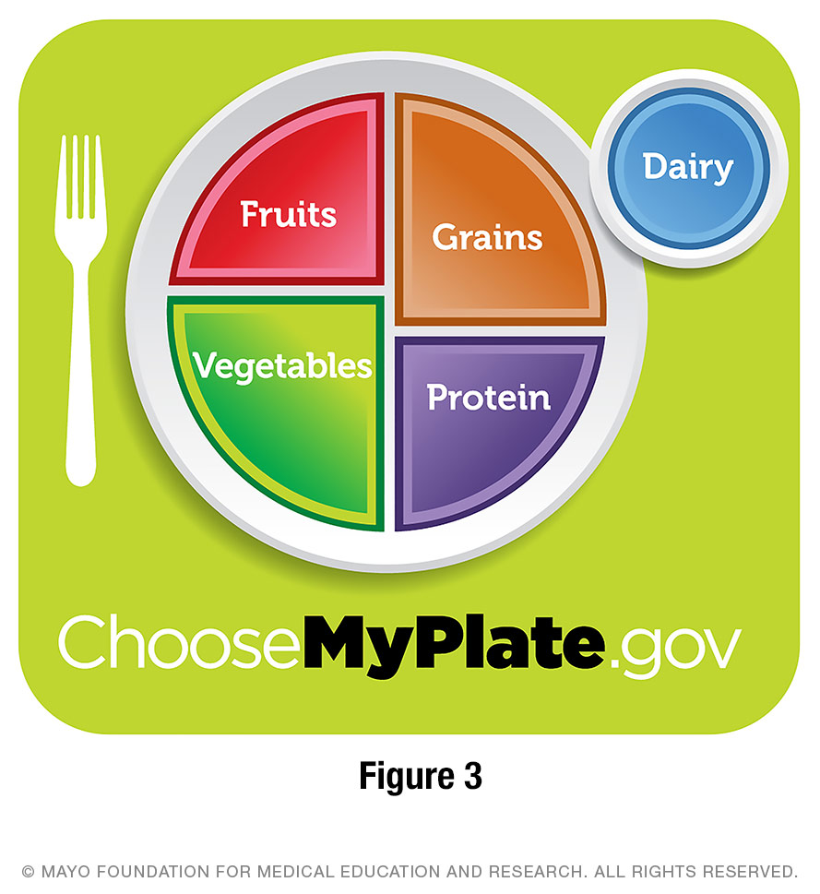

Sample grain servings
Include gluten-free breads, cereals and other gluten-free grain products. These are good sources of B vitamins, iron, fiber, and energy. The following examples show gluten-free grains and starches and healthy serving sizes to use.
- 1 cup dry gluten-free cereal
- 1/2 cup cooked gluten-free cereal, rice or other cooked grain
- 1/2 cup gluten-free pasta
- 1 slice gluten-free bread
- 1 corn tortilla

Get plenty of whole-grain foods
After you adjust to a gluten-free diet, try to use more whole grains and fewer refined grains in your meals. Whole grains are generally higher in fiber and other nutrients than processed grain products.
Look for grain products that are enriched or fortified with B vitamins and iron. Many gluten-free grains and cereals are not fortified with added vitamins.
Gluten-free whole grains include:
- Amaranth, amaranth cereals and flour
- Buckwheat and buckwheat groats (kasha)
- Corn, cornmeal and popcorn
- Flax
- Millet cereal and flour
- Gluten-free oats
- Quinoa, quinoa flakes and quinoa flour
- Brown rice
- Wild rice
- Sorghum
- Teff

Make Your Favorite Recipes Gluten-Free
To make gluten-free versions of favorite recipes, you may need to make some changes.
Follow these general guidelines:
- When you use gluten-free flours, you may need to adjust other ingredients in the recipe, such as oil and eggs.
- For better baked goods, combine different types of gluten-free flours. To make an all-purpose baking mix, combine 2 cups of white rice flour, 1 cup of potato starch and 1 cup of tapioca flour.
- Use xanthan gum, a baking ingredient for gluten-free products. Xanthan gum holds ingredients together and provides leavening and texture. You can find it in some grocery stores in the health food section or in health food stores. And you can order it from mail-order companies. Use 1 teaspoon xanthan gum per cup of flour or baking mix.
- When you use substitute starches and flours, you may need to bake longer and at a lower temperature than you do for wheat flour.
- You can purchase gluten-free baking mixes that substitute 1-for-1 in any recipe calling for wheat flour.
- To thicken, try using cornstarch, tapioca, arrowroot flour, or a gluten-free flour.
To replace breadcrumbs, try using:
- Cornmeal.
- Crushed potato or corn chips.
- Crushed gluten-free crackers.
- Crushed gluten-free rice or corn cereal.
- Ground nuts, such as almonds and walnuts.
- Ground seeds, such as sesame and pumpkin.
Gluten-free baking and cooking can take trial and error. But there are many good gluten-free cookbooks you can buy or check out from the library. You also can find recipes on the internet.

Gluten-Free Diet: Some Tips to Save Money
- Choose foods that are naturally gluten-free. These include foods such as fruits, vegetables, fresh meats, poultry, fish, eggs, legumes, nuts, and dairy.
- Eat potatoes and rice more often and save pasta for a change of pace.
- Look online for coupons.
- Check the food label ingredients on brands you already use. Many may be gluten-free.
- Buy an economy size or buy a case. Then store or freeze gluten-free items for future use.
- Join a celiac disease support group to get advice, share bulk food purchases, sample foods before you buy them, and find out about local resources.
- Shop in the grocery store's Asian section or in an Asian store for rice noodles and crackers.
- Use a corn tortilla instead of bread or in place of a regular pizza crust.
- Pack your lunch and snacks for work. Take leftovers or salads instead of sandwiches.
- Save gluten-free cookies or cake for an occasional treat. Have fruit or ice cream for dessert.
- Snack on fruits, vegetables, plain potato or corn chips, and nuts or popcorn instead of expensive gluten-free snacks.
- Buy vegetables and fruits in season. Shop at a farmer's market.
- Eat out less frequently.
- Bake from scratch. Find recipes in a gluten-free cookbook or online.
- Skip sodas and bottled water.

Tips to get you started
- Focus on foods that you can have, such as meat, poultry, fish, potatoes, rice, vegetables, and fruit.
- Shop on the outside edges of the grocery store. This is where you will find fresh foods that have not been processed. This also can make it easier to read labels as you get used to doing that.
- Go through your kitchen cupboards and find the foods you can still eat.
- Shop in the gluten-free section of the supermarket.
- Buy a gluten-free cookbook or look online for recipes.
- Learn a few basic meals to prepare instead of eating out or using convenience foods.
- Discuss with your family how you are going to rearrange your kitchen to prevent cross-contamination.
- If there are family members who eat foods with gluten, create a space in your kitchen to store your gluten-free foods away from family foods that contain gluten.
- Join a support group for people with celiac disease.

Sample Menu Ideas

Breakfast
- Gluten-free corn flakes, Corn Chex™ or other gluten-free corn cereals.
- Rice Chex™, Cream of Rice™ or other gluten-free rice cereals.
- Gluten-free Cheerios™.
- Gluten-free oatmeal.
- Eggs, omelets made with cheese or vegetables.
- Hash browns, potato patties without gluten.
- Ham, bacon or sausage.
- Gluten-free bread, toast, bagels, or English muffins.
- Gluten-free pancakes with syrup.
- Gluten-free waffles or frozen waffles.
- French toast made with gluten-free bread.
- Fruit.
- Yogurt.
- Peanut butter.
- Milk, fruit juice, coffee, tea, or homemade smoothies.

Lunch
- Salads with gluten-free lunch meat, chicken, tuna, egg, sunflower seeds, black beans, chickpeas, tomatoes, cucumbers, shredded carrots, vegetables, and allowed dressing.
- Homemade chili with allowed ingredients.
- Homemade soup with allowed ingredients.
- Leftovers from dinner.
- Sandwich made with gluten-free bread or gluten-free wraps. Use gluten-free lunch meat, chicken, tuna salad, egg salad, cheese, lettuce, tomato, onion, and mayonnaise.
- Tacos with seasoned ground beef, lettuce, tomato, salsa, olives, cheese and sour cream.
- Nachos topped with cheese.
- Baked potato topped with gluten-free chili or cottage cheese.
- Gluten-free baked beans with ham slices or gluten-free hot dogs.
- Gluten-free frozen meals, such as Amy’s™ brand.

Dinner
- Lean meat.
- Meatloaf made from lean ground meat mixed with egg, gluten-free oatmeal, and allowed seasonings.
- Chicken.
- Turkey.
- Fish.
- Shellfish.
- Stir fry with gluten-free soy sauce.
- Steamed white, brown or wild rice.
- Baked, boiled or mashed potatoes.
- Quinoa.
- Rice or corn pasta with gluten-free pasta sauce.
- Taco salad.
- Omelets.
- Gluten-free pizza.
- Vegetables.
- Fruit.

Snacks
- Cheese or cottage cheese.
- Yogurt.
- Pudding.
- Ice cream, sherbet.
- Plain corn chips.
- Nuts and seeds.
- Plain potato chips.
- Popcorn.
- Popcorn cakes.
- Raw vegetables, such as carrots, cherry tomatoes, cucumber, and other allowed vegetables.
- Rice cakes.
- Peanut butter on celery, apples or gluten-free crackers.
- Gluten-free crackers with cheese.
- Hummus.
- Gluten-free granola bars.
- Gluten-free trail mix with nuts, chocolate chips, dried fruit, and seeds.

For More Information
If you have questions about celiac disease, dermatitis herpetiformis, a gluten-free diet, or about this information, talk with your dietitian or your health care provider.
Registered dietitian ________________________________________
Health care provider ________________________________________
Other contact ________________________________________
This material is for your education and information only. This content does not replace medical advice, diagnosis or treatment. New medical research may change this information. If you have questions about a medical condition, always talk with your health care provider.
- © 2021 Mayo Foundation for Medical Education and Research (MFMER). All rights reserved.
MC1221rev0121

