Patient Education: Bravo
Your Procedure:
Dr.______________________________ Date: _______________ Arrival Time: _______________
Location: WellStar Outpatient Surgery Center- 3000 Hospital Blvd, Roswell Ga, 30076
See last page for further location instructions.
Please Park in the ramp and walk over to the main entrance of the hospital. Check in @

What is Bravo? Bravo is a minimally invasive procedure that evaluates heartburn or other symptoms associated with Gastroesophageal Reflux Disease (GERD). Long term symptoms of GERD can lead to serious medical problems such as: difficulty swallowing, narrowing of the esophagus, or a disorder called Barrett’s esophagus which can lead to esophageal cancer.
How will I prepare for a Bravo procedure?
- Diet restrictions: Nothing by mouth after midnight, except for small sips of water with medications, up to 2 hours before procedure.
- Your provider will give you instructions on when to stop your acid suppression medications, prior to the procedure.
- During the procedure, an anesthesia provider will give you medication to keep you comfortable. It is not safe to drive after receiving these medications, so you will need to find a driver that is 18 years of age or older, to drive you to your procedure, be onsite during the procedure, and stay with you for 24 hours after your procedure. *If you do not have a driver, you will not be able to have your procedure.
Is the procedure safe? Serious complications are rare, but all procedures have potential risks. Risks include, but are not limited to:
- Bleeding
- Small tear in the esophagus
- Discomfort at the capsule site
Contraindications to Bravo are as follows:
- Pacemaker/defibrillator, bleeding problems, taking blood thinners, severe esophagitis, esophageal varices, or presence of a stricture/obstruction.
- The bravo capsule contains stainless steel. If you have allergies or sensitives to chromium, nickel, copper, cobalt, or iron, please notify your provider.
What Can I Expect During the Procedure? When you arrive at the hospital, a staff member will go over your medical history, further discuss the procedure & answer your questions. You will then be taken back to the procedure room.
Your physician will then attach the Bravo capsule to the wall of your esophagus with a small delivery device. The capsule is about the size of a multivitamin capsule. This capsule will measure the pH of your esophagus and relay it to the recorder, which you will wear. You will wear the recorder for 48-96 hours. The procedure to place the capsule only takes a few minutes.

What Can I Expect After the Procedure?
- You might have the sensation of something in your throat.
- You will be able to go home, and resume normal activities such as eating, drinking, sleeping, bathing, and exercising if you always stay within 3 feet of the data recorder.
- You will need to document the start and stop time when you sleep/laydown or eat/drink.
- You will need to document when you are having symptoms such as heartburn, indigestion, or chest pain.
- After your test is complete (48-96 hours) you will need to return the equipment to your providers office. Your provider will then be able to view your test results.
- The capsule will naturally release from your esophagus and pass naturally in your stool.
- Avoid having an MRI for at least 30 days after Bravo placement.
Directions to 3000 Hospital Blvd, Roswell Ga, 30076
- From Alpharetta Hwy:
Turn into WellStar North Fulton Hospital and drive pass the front entrance. Continue straight; make a left towards the Outpatient Surgery Center. Drop the patient off at the drive under and straight ahead you will see parking for outpatient surgery.
- From Hembree Rd:
Turn into WellStar North Fulton Hospital, make a right towards the Outpatient Surgery Center. Drop the patient off at the drive under and straight ahead you will see parking for outpatient surgery.

Patient Education: Managing My Bravo Procedure at Home
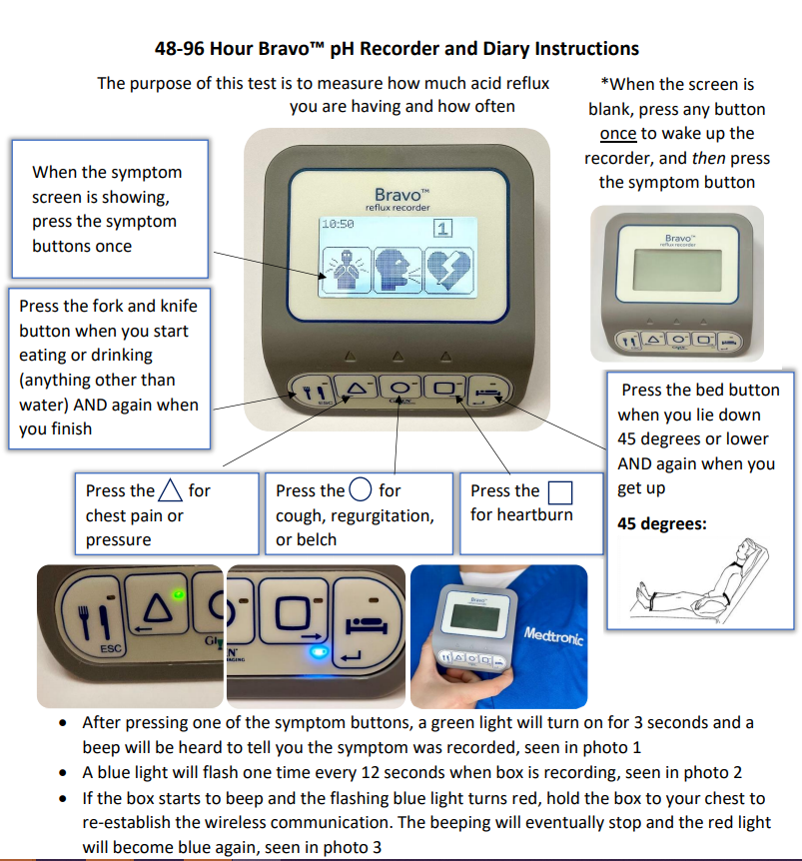

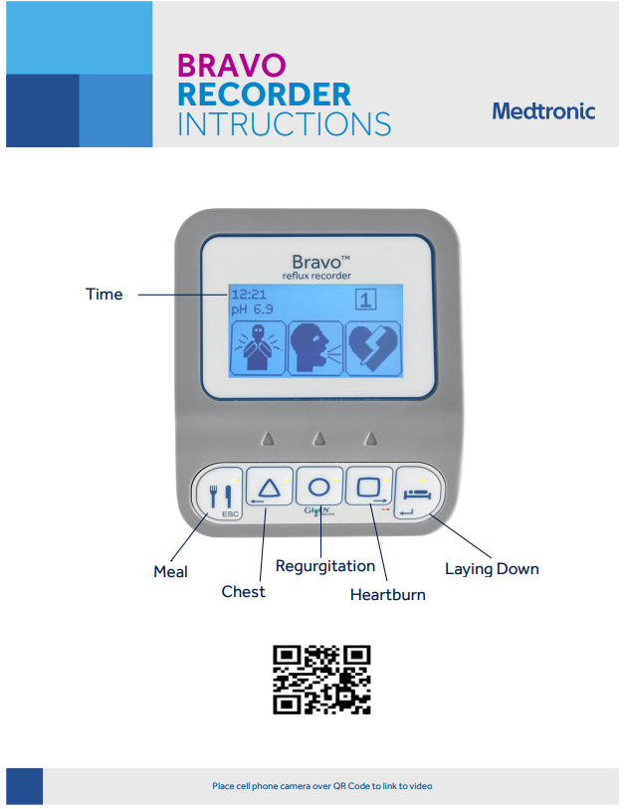

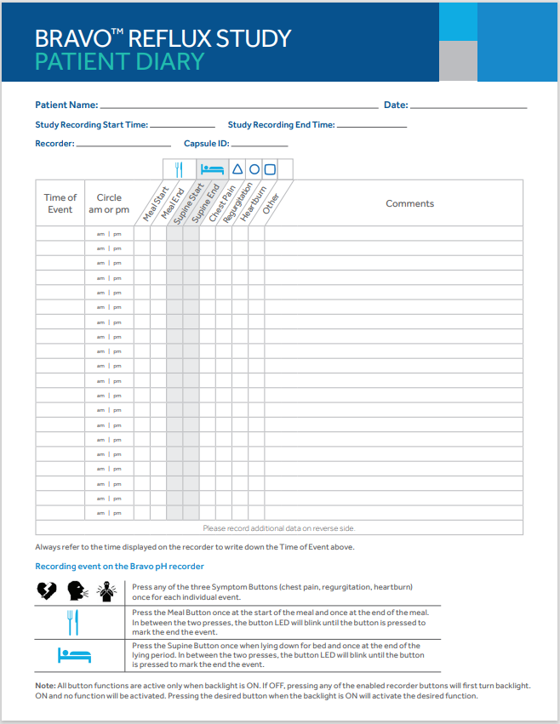
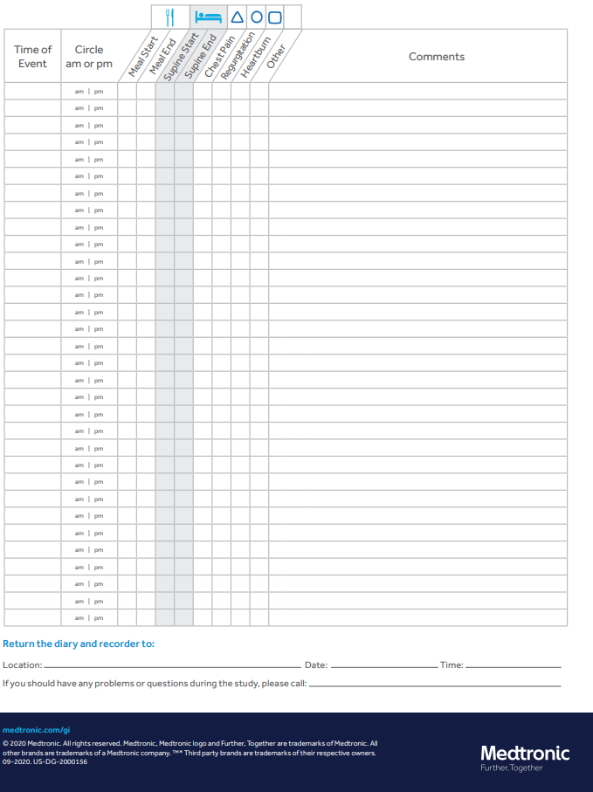
Patient Education: After My Bravo Procedure
- Always stay within 3 feet of your bravo recorder.
- You might have the sensation of something in your throat. Chewing your food carefully and drinking fluids can decrease this sensation.
- Resume normal activities such as eating, drinking, sleeping, bathing, and exercising if you always stay within 3 feet of the data recorder.
- If you received sedation/anesthesia for your procedure, no driving for at least 24 hours and do not make important decisions the day of the procedure.
- Document the start and stop time when you sleep/laydown, eat/drink, and when you experience symptoms such as heartburn, indigestion, or chest pain.
- The capsule will naturally release from your esophagus and pass naturally in your stool.
- Avoid having an MRI for at least 30 days after Bravo placement.
- If you have any questions/concerns at any time, call 470-267-1520
- If you experience bleeding or extreme pain, please go to the emergency room
- Return all Bravo equipment, accessories, and Bravo Patient Reflux Diary to the registration desk where you checked in for your Bravo procedure. No later than:
  - Date: ______________
  - Time: ______________

